Rebuilding the Installer

After changing the code:

1. Make sure your Visual Studio installation has the plugin “Microsoft Visual Studio Installer Projects”. If not, download it and restart VS.
2. Open InterfaceTestTool.sln in Visual Studio (in folder InterfaceTestTool).
3. 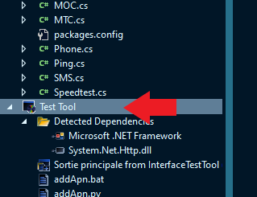In solution Explorer, delete the Test Tool Setup Project (right-click, delete):
4. 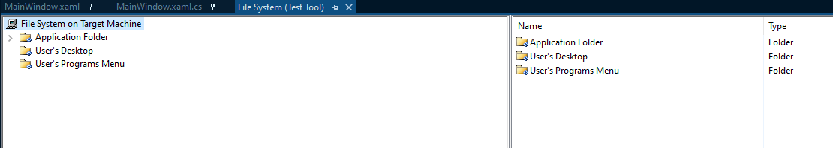Go to File > New > Project, select Setup Project and give it a name. **Under ‘Solution’, choose Add to Solution**, then click Create. It should open a File System window like so.
5. In Application Folder, create a folder named Test Tool

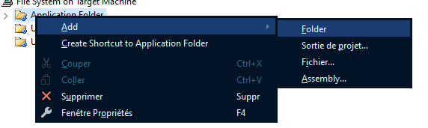

1. In this folder, drag and drop the following files and folders:

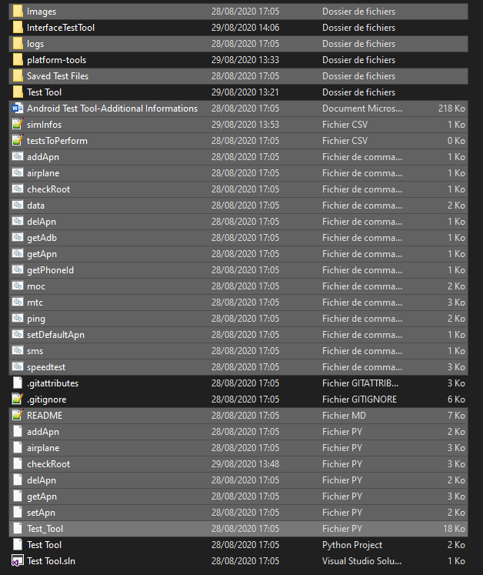

1. Right-click in the right pane and add Project Output. Make sure to select Configuration “Release”:

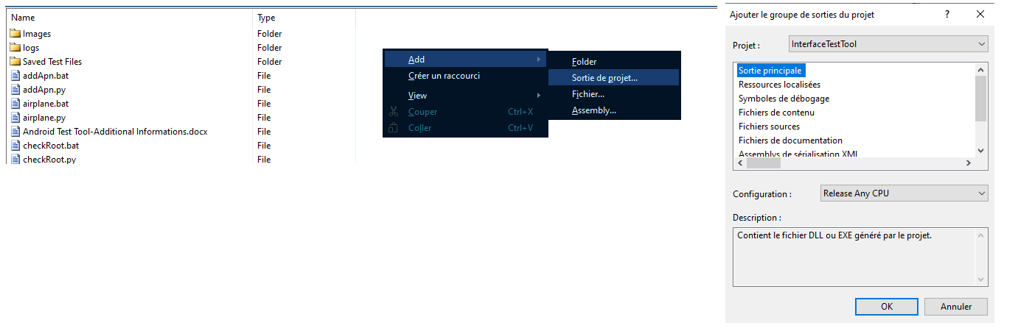

1. Once it is done, you can automatically add shortcuts to the Desktop and Start Menu by right clicking the newly created Project Output and “Create Shortcut”. Don’t forget to set the icon of the shortcuts by right-clicking and selecting Properties > Icon > Browse…. The icon is in the Images folder.
2. Then, build your project with Ctrl + B. You will find the ‘setup’ file in the Folder of the name of your Setup Project, under Debug or Release

